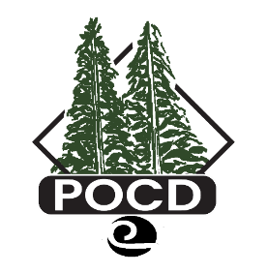

Pend Oreille Conservation District
Regular Board Meeting AGENDA: Attachment (A)

The regular Board meeting for April 15, 2025, has been cancelled.

